**User Interfaces**

Below are shown some mockups that shows the general aspect, structure and main functionalities of the mobile and web application. Note that these mockups are only indicative, and the final version of the application may considerably differ.

*Mobile Application*

*Home -* This is the layout of the main screen of the mobile application:

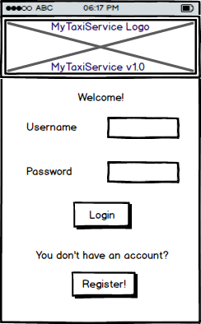

*Registration -* If the user taps on the “Register!” button from the application home, the following screen will appear:

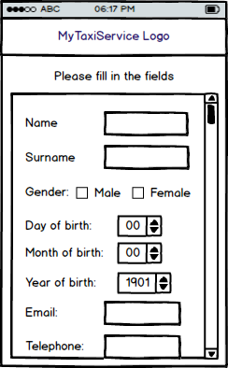

In the final version some of the fields may be marked as compulsory.

*Taxi Driver Home –* If a user logs in with taxi driver’s credential from the application home, the following screen will appear:

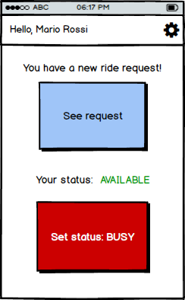

The “See request” button, as long as the “You have a new ride request” text, may not be present if no request have been received.

*Taxi driver request details –* The following mockup shows what the user will see if he presses the “See request” button from the previous screen.

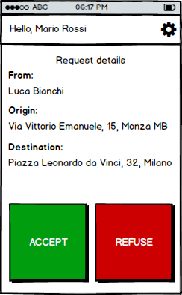

Note that the “Destination” field may be empty if the customer has not compiled it while making the request. If the user presses the “REFUSE” button, the *Taxi driver request details* will appear, otherwise the following screen will be loaded:

*Taxi driver busy status –* This screen may be reached either by pressing the “ACCEPT” button in the *Taxi driver request details* or by setting the busy status in the *Taxi driver home*.

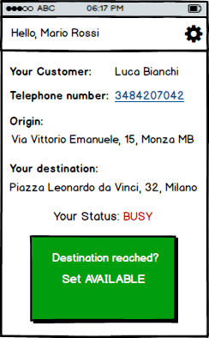

No customer information will appear if the taxi driver picks up a standard customer.

*Customer home –* This mockup shows the screen that will appear after a customer has finished the login procedure:

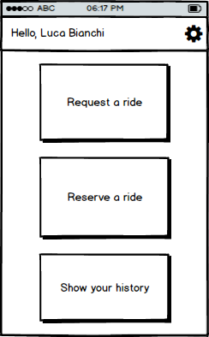

*Customer ride request –* This screen shows what happens when the “Request a ride” button is pressed in the *Customer home*.

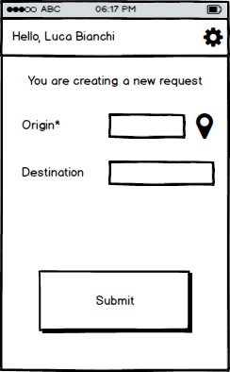

The asterisk indicates that the Origin field is compulsory, while the localization symbol indicates the possibility to locate the origin using the phone’s GPS system (if present).

*Customer ride reservation -* This screen shows what happens when the “Reserve a ride” button is pressed in the *Customer home*.

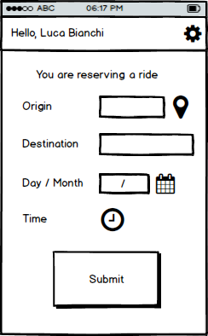

*Customer history –* After pressing the “Show your history” button, the following screen will appear:

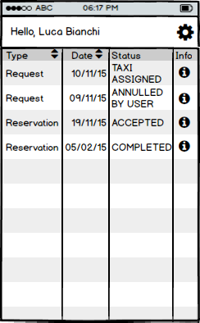

*Customer Request/Reservation Info -* By pressing the Info symbol in the *Customer history* screen, details about the request or reservation will be shown as follows.

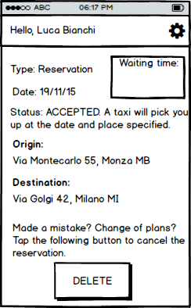

The “Waiting time” box will be filled with the time to wait for the taxi to arrive only when a taxi driver will be assigned to the customer.